**Instructions to install PCB library for ECE Parts in Altium Designer**

All the parts in ECE stock inventory are now available in a pcb library (EceParts.dblib)

This library is available on all ECE undergraduate lab machines as well as most of the research lab machines.

Open Altium Designer.

Open an existing project or create a new project.

Open Libraries panel

Click on Libraries

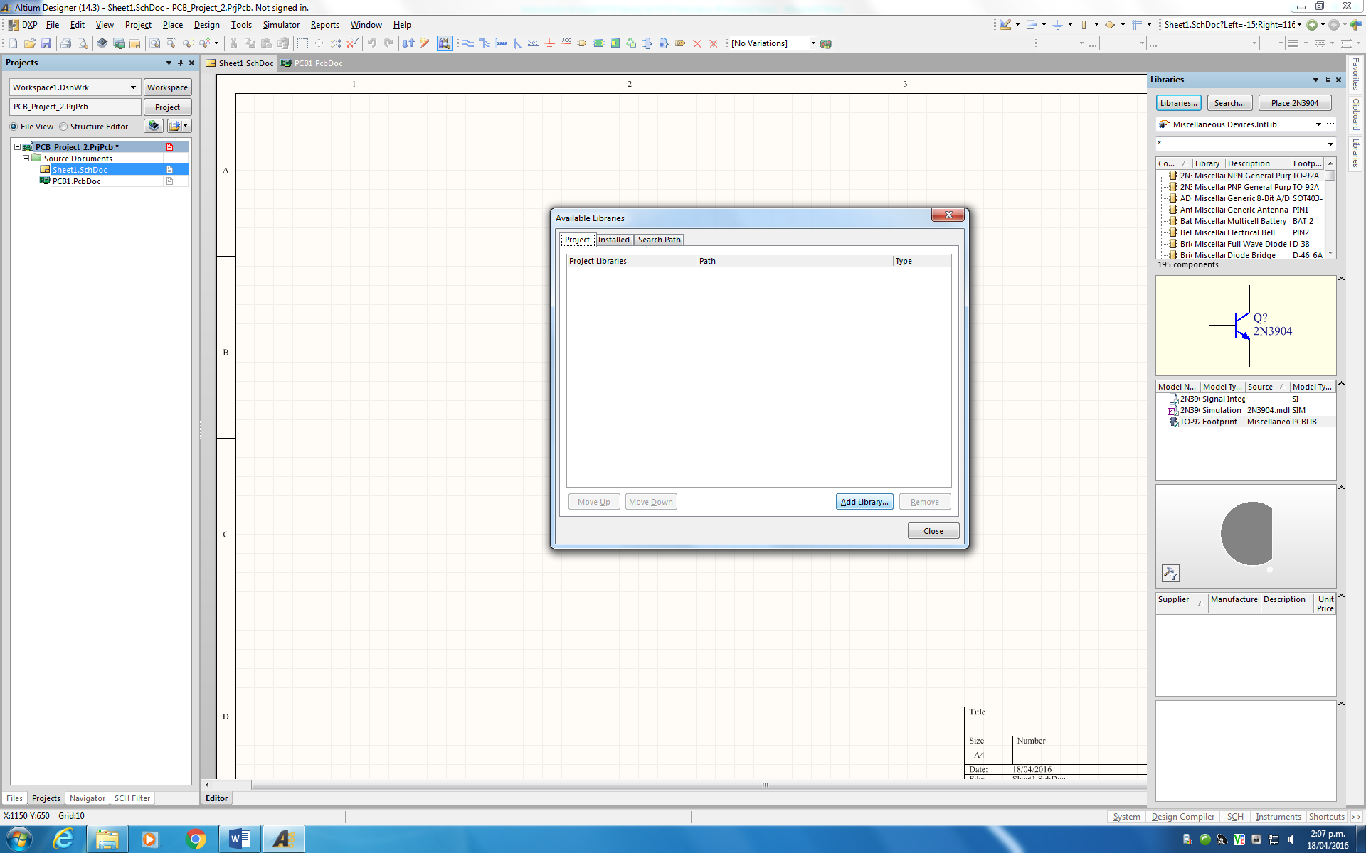

Click on Project Tab (This will add libraries to the project)

Click on Add Library

Choose file type as DBLIB

Select path for database library which is,

**S:\ECE\PCB_Libraries\ECE-Parts and select EceParts.DbLib**

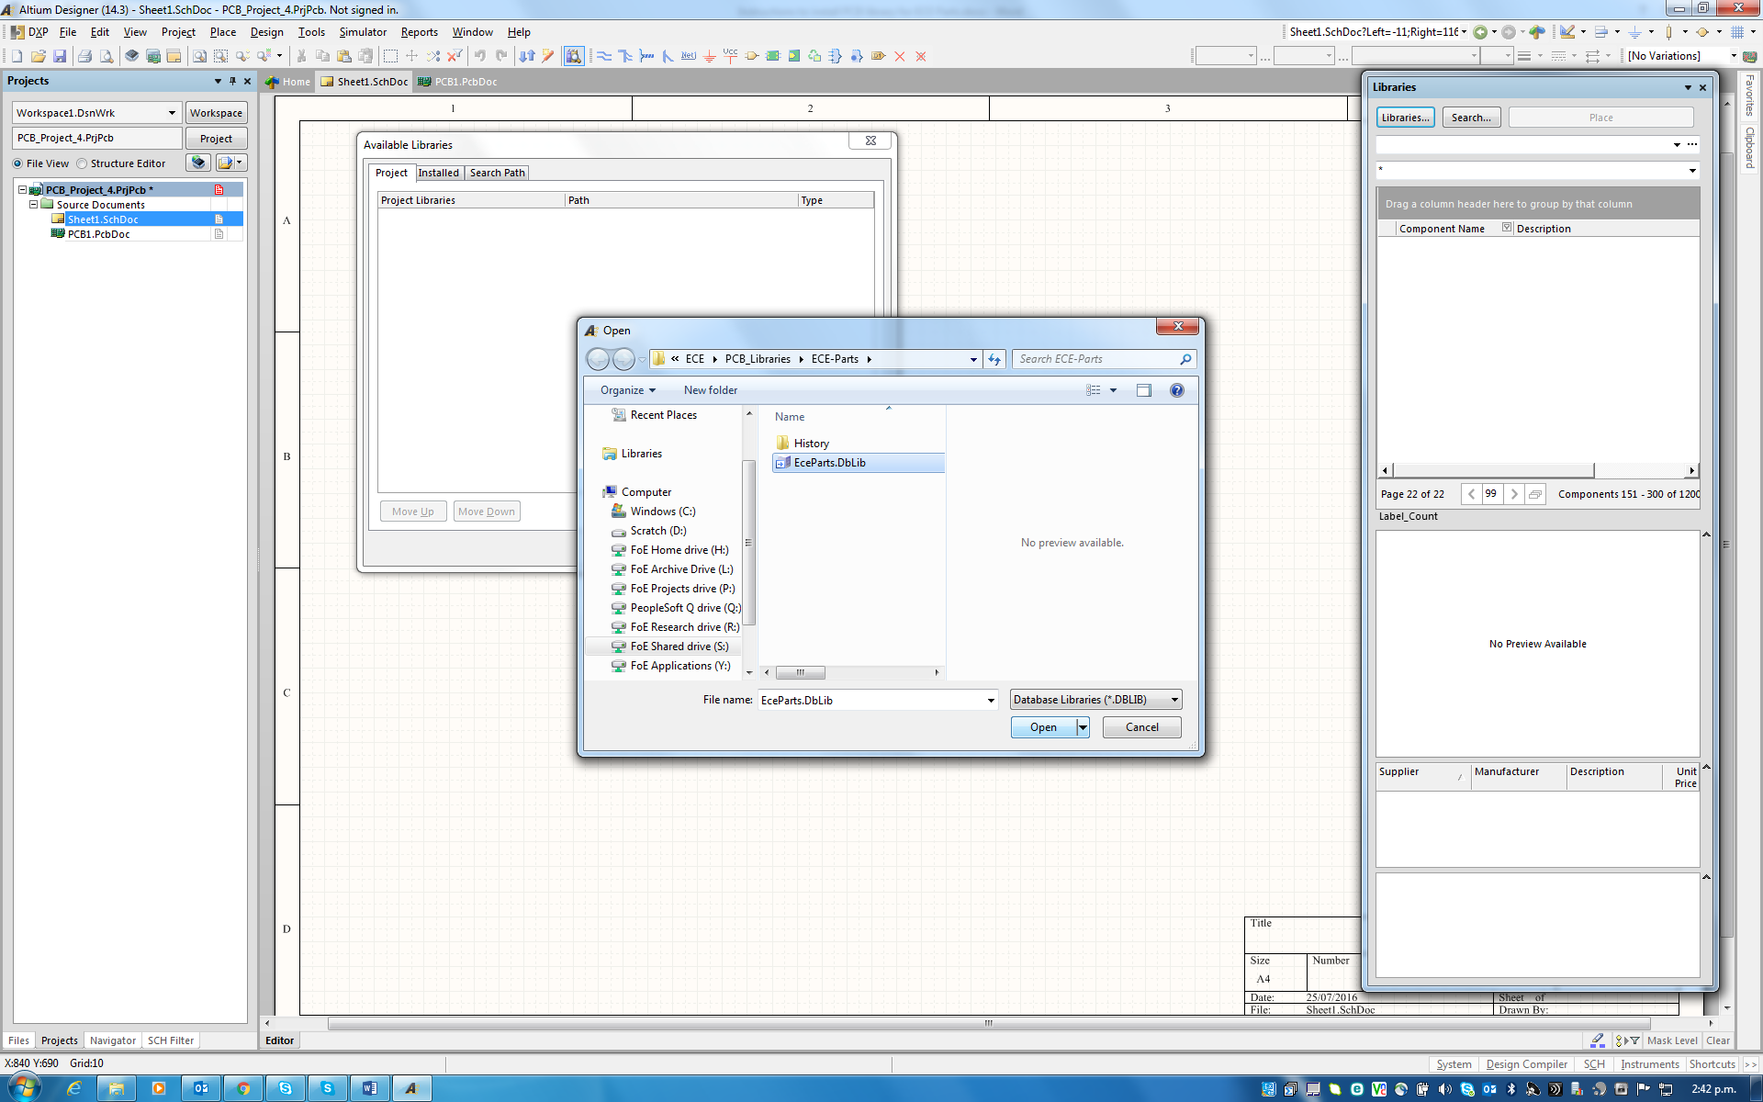

Click Open

And then click close on Available Libraries Panel

You can now see the EceParts.DBLIB with several tabs from capacitors, connectors etc. Each type of component is listed under a separate category.

You can change the view of library panel, so that you can see the key information about each part.

Right click on library panel and click select columns

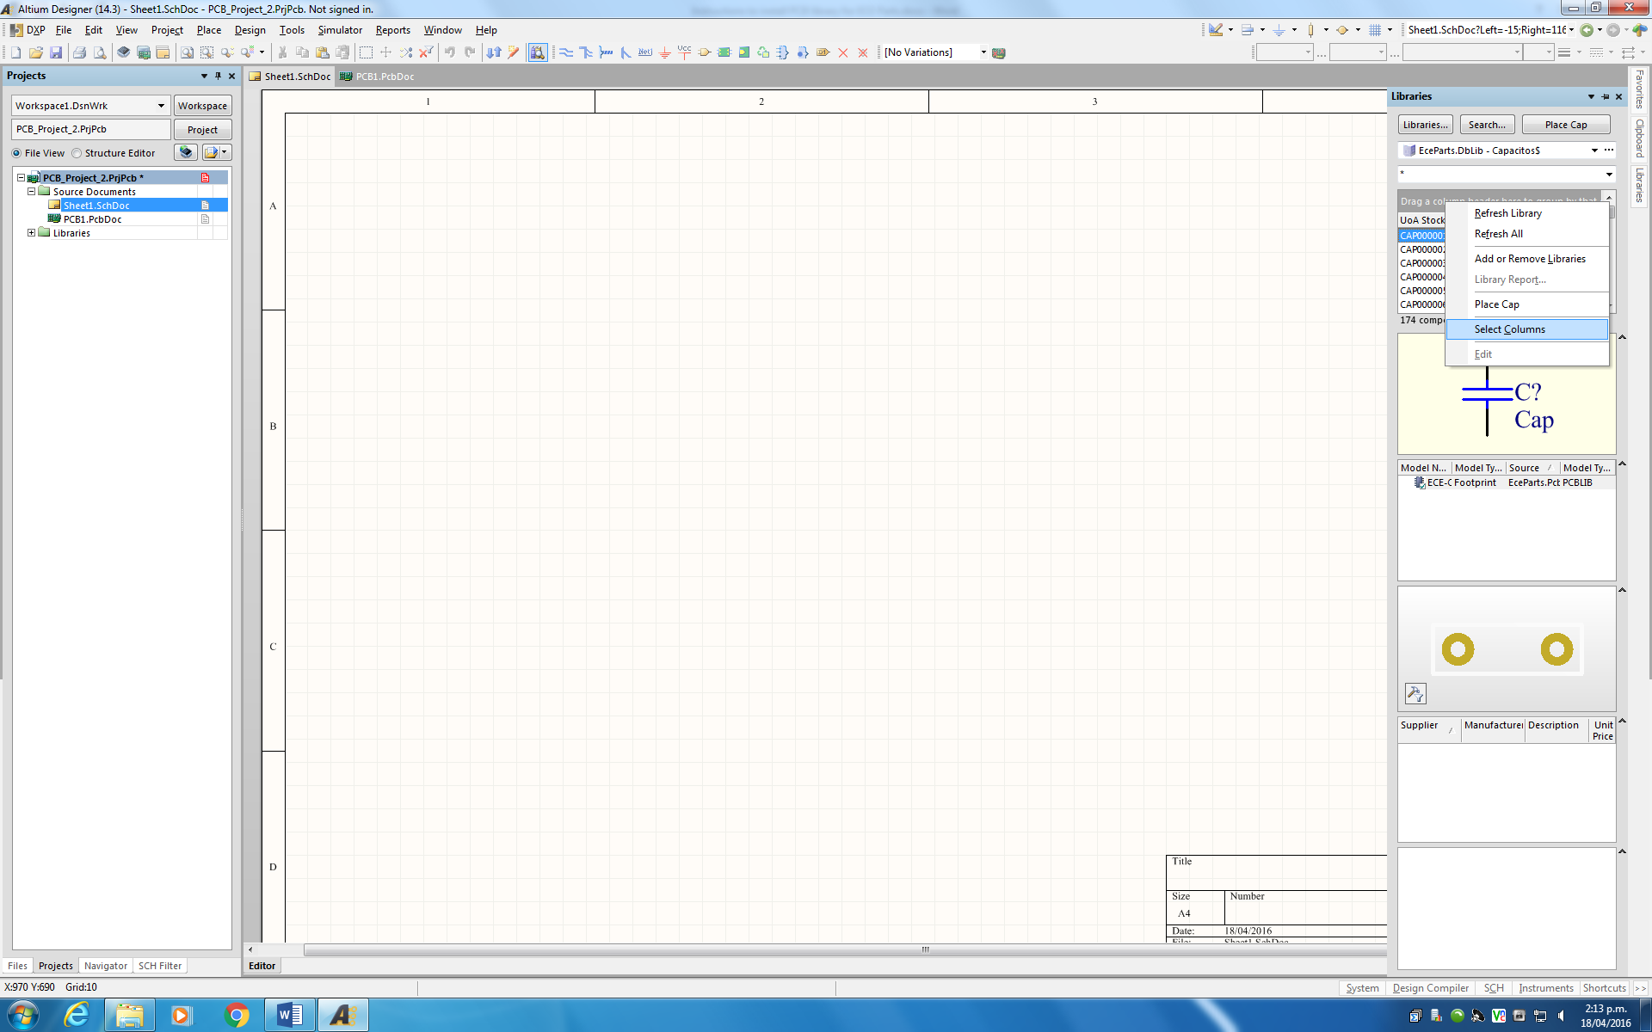

From this menu, you can select specific columns (information) you would like to see in the library panel. You can also delete the columns you don’t want.

To delete a column, select the column from the **Selected Parameters** and click **<Remove**

To add a column select a parameter from **Known Parameters** and then click **Add >**

Select following parameters to give maximum specification about the parts.

Comment

Desciption

Size/package

Manufacturer p/n

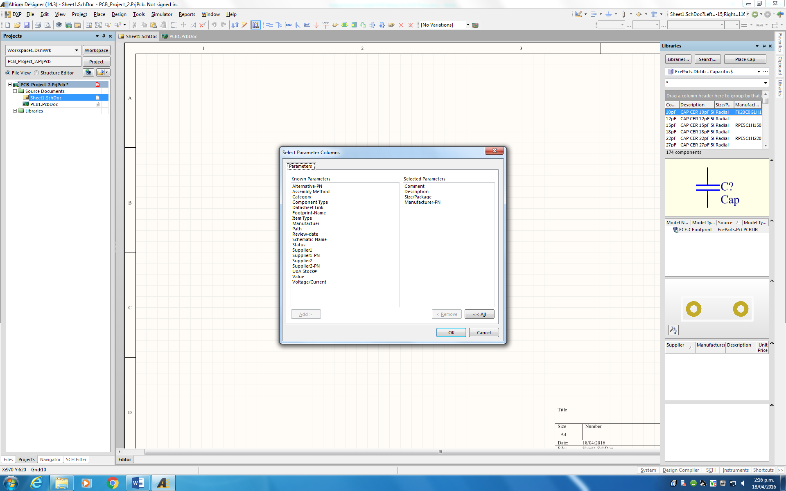

The library Panel should look like this,

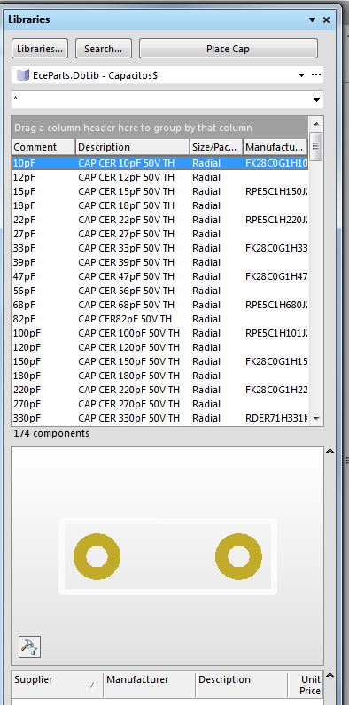

Now you can start placing parts from this library.

There is a library part for each value of resistor or capacitor. So you can choose the correct value part. There is no need to modify values once the part is placed.

Once the part is placed, double click on the part and in the Parameters window, you can see all the parameters for this part including the manufacturer part number & Supplier Part number.

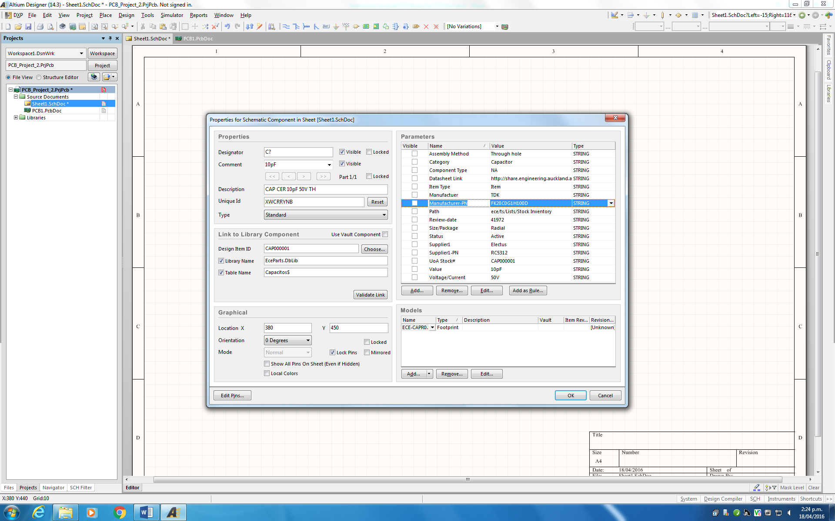

Database library lists all the parts visible on ECE Components Stock Inventory database available on Staff/Student page of ECE intranet.

<http://www.ece.auckland.ac.nz/en/for/current-students/ece-student-resources.html>